Voice Is the Next Cyber Attack Surface
AccuKnox Zero Trust Stateful Firewall

For thirty years, “input” meant a keyboard, and cybersecurity built its entire vocabulary around that assumption: sanitize the field, validate the payload, rate-limit the endpoint. That assumption is now obsolete. Voice assistants sit in billions of homes, cars, and pockets; enterprises are wiring voice into help desks, banking apps, and industrial controls; and the defense and robotics communities are racing to give autonomous systems natural-language ears. Voice is becoming the next keyboard — the primary way humans, and soon machines, will issue intent to AI systems.
The problem is that a microphone doesn’t know the difference between a legitimate user and a cloned voice, a spoken command and an inaudible ultrasonic one, or a genuine conversation and a scripted social-engineering routine. Researchers have spent the last decade proving, again and again, that voice interfaces can be fooled, hijacked, and weaponized — and the defenses built so far are only partially keeping up. This piece walks through where the threats stand today, why current mitigations fall short, and how AccuKnox’s Zero Trust Voice Firewall approaches the problem differently: by treating a voice interaction as a stateful conversation rather than a stateless prompt.

1. Current and Emerging Threats
Voice-based attacks fall into a handful of recurring families, each backed by a growing body of academic and industry research. Taken together, they show that almost every layer of a voice pipeline — the microphone, the speaker-verification model, the speech-to-text engine, the third-party “skill,” and the conversation itself — has a documented exploit path.
Deepfake and cloned voices. Text-to-speech and voice-conversion models can now clone a voice from a short sample and use it to defeat speaker-verification systems or impersonate a trusted person on a phone call. Evaluations of commercial voice-cloning services found that generic speaker-verification models were bypassed by every synthetic sample tested, and even robust, text-dependent systems like Siri and Bixby failed against high-fidelity cloning roughly half the time. In the corporate world, this has already moved from theory to headline: attackers used a cloned CEO voice on a video call to try to trick employees at a global advertising firm into transferring funds and disclosing sensitive information.
Inaudible and ultrasonic command injection. A device’s microphone can pick up frequencies humans can’t hear. DolphinAttack showed that ultrasonic signals can silently trigger “Hey Siri” or “OK Google” and issue commands with no audible trace. Near-Ultrasound Inaudible Trojans (NUIT) push this further, chaining a compromised smart speaker to a phone, then to a smart lock, then to physical access to a laptop — all without a sound a person could hear. SurfingAttack exploits the non-linear response of the tiny MEMS microphones inside phones and speakers, using guided ultrasonic waves that can even travel through a solid desk to reach a device. The same physics has been shown to physically damage hard-disk drives by vibrating the read/write head with ultrasonic tones — turning “sound” into a hardware-sabotage vector, not just a software one.
Adversarial audio and hidden commands. Carefully crafted noise, phase-shifted audio, or “unintelligible” hidden voice commands can be interpreted by speech recognition engines as clear instructions while sounding like static or nothing at all to a human listener. Methods such as AdvPulse and SpecPatch show that a short, universal audio “pulse” can hijack a running command regardless of what benign speech surrounds it.
Skill and third-party function abuse. Once a voice assistant supports third-party “skills” or “actions,” a whole new attack class appears. Voice squatting registers a skill with a name that sounds like a popular one (“Capital Won” for “Capital One”) to hijack the invocation. Voice masquerading has a malicious skill fake a hand-off to another skill, or fake its own termination while continuing to record, all while the user believes they’re speaking to a trusted service. Field deployments of proof-of-concept skills showed thousands of real users were confused into interacting with the wrong skill within weeks.
Vishing, voice identity theft, and voice-messaging attacks. Voice phishing has always relied on social engineering, but generative AI has made it essentially free to produce convincing, individually tailored scripts and cloned voices at scale — the UK’s National Cyber Security Centre flagged this as one of the fastest-escalating phishing vectors. Malicious voicemails delivered over WhatsApp, Messenger, or classic phone systems have been used to spread trojans, sometimes triggered by nothing more than pressing “play.”
Multi-turn, conversational manipulation. The newest and least-defended category doesn’t rely on any single malicious utterance at all. Instead, an attacker builds up a malicious final instruction over several natural-sounding exchanges (prompt chaining), manufactures false urgency through tone and pacing (prosody manipulation), or introduces conflicting text/audio cues to desynchronize an AI system’s understanding of intent (cross-modal drift). These attacks are specifically designed to slip past filters that only ever look at one prompt at a time.
Table 1 — Representative voice attack techniques
Attack family | Representative technique(s) | What it exploits
Deepfake / voice cloning | TTS & VC synthesis, cloned-CEO vishing | Speaker verification, human trust in familiar voices
Inaudible / ultrasonic injection | DolphinAttack, NUIT, SurfingAttack | Microphone nonlinearity, frequencies outside human hearing
Hardware-level sabotage | Ultrasonic HDD interference | Mechanical resonance of disk components
Adversarial / hidden commands | AdvPulse, SpecPatch, hidden voice commands | Gaps between human perception and ASR decoding
Skill / third-party abuse | Voice squatting, voice masquerading | Ambiguous invocation names, lack of skill vetting
Vishing & identity theft | AI-scripted calls, cloned-voice impersonation | Social engineering, urgency, authority cues
Conversational manipulation | Prompt chaining, prosody manipulation, cross-modal drift | Single-turn, stateless filtering

The pattern across every one of these families is the same: attackers are no longer just trying to fool a person on the other end of a call. They are treating the AI system itself as the target, and the conversation — not a single command — as the attack surface.
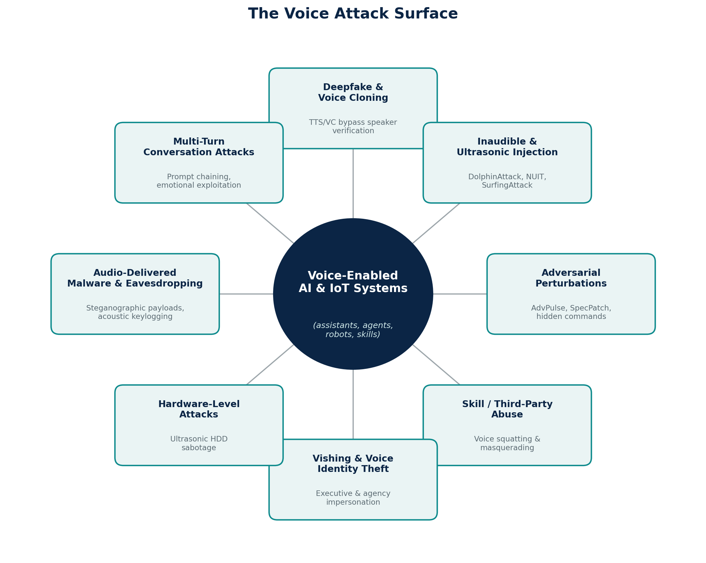
Figure 1. The voice attack surface: eight recurring attack families converging on voice-enabled AI and IoT systems.

2. Pitfalls and Shortcomings of Current Solutions
Defensive research has kept pace in places, but every mitigation deployed so far comes with a meaningful trade-off, and none of them were designed with today’s conversational AI agents in mind.
Liveness detection trades false rejections for security. Systems that try to distinguish a live human voice from a replayed or synthesized one are genuinely effective against many attacks — but they also reject a nontrivial share of real human speech, especially in noisy or informal settings. Evaluations of liveness-detection tools found real human speech failing the check a meaningful fraction of the time, which pushes organizations toward the opposite failure mode: turning sensitivity down until legitimate users stop getting locked out, which is exactly what makes systems like Alexa (no built-in speaker verification for most commands) easier to activate — and easier to abuse.
Signal-processing “purification” degrades under real-world conditions. Filtering techniques such as down-sampling, quantization, or mel-spectrogram reconstruction can strip out some adversarial perturbations, but they lose effectiveness precisely when perturbations are strongest — during real over-the-air attacks — and they measurably degrade the audio quality of legitimate commands in the process.
Adversarial training is expensive and self-defeating. Training a speech model to resist adversarial examples cuts attack success rates, but it also reduces accuracy on ordinary, clean audio and can take more than ten times longer to train — a cost most product teams are not willing to pay for a threat they haven’t yet experienced.
Skill ecosystems still have essentially no vetting. Marketplace studies found thousands of skills with confusingly similar invocation names, and demonstrated that attacker-registered skills sailed through both Amazon’s and Google’s certification processes. Because a skill is really just a web service the developer controls, nothing stops its behavior from changing after approval — static vetting can’t see what the server does at runtime.
Detection stays stateless while attacks go conversational. Even the best academic defenses against masquerading and context-switching attacks — natural-language classifiers that flag suspicious skill responses or user intent — report strong precision in the high-90s, but acknowledge they cannot guarantee comparable recall across the enormous, constantly-growing volume of real-world conversations. Meanwhile, most production filters still evaluate one instruction at a time, which is structurally blind to attacks explicitly designed to unfold across several turns.
Ultrasonic and hardware-layer attacks bypass software defenses entirely. No amount of speaker-verification tuning helps when the exploit lives in the physics of a MEMS microphone or a spinning disk platter. These attacks don’t touch the software stack at all until after the damage is done.
Governance and legal frameworks lag behind the technology. Analyses of national cybersecurity law and SEC disclosure rules both point to the same structural gap: legal systems built around “unauthorized access to an information system” don’t cleanly cover inaudible acoustic manipulation or AI-driven impersonation, and regulators (and CISOs) are still working out how “materiality” applies to an AI-enabled incident that unfolds in minutes rather than days.
Table 2 — Common defenses and their limits
Defense | What it does | Key shortcoming
Liveness detection | Flags replayed / synthetic audio | High false-rejection rate on genuine speech; forces a sensitivity/security trade-off
Signal purification (filtering, resampling) | Strips adversarial perturbations | Fails against strong, over-the-air perturbations; degrades legitimate audio
Adversarial training | Hardens ASR/SV models | >10x training cost; reduces clean-audio accuracy
Skill/marketplace vetting | Certifies third-party voice apps | Checks are static and pre-approval only; server logic can change afterward
ML-based conversation classifiers | Flags masquerading / context switches | Strong precision, unproven recall at scale; still largely single-session
Legal / regulatory frameworks | Defines liability and disclosure duties | Written for “systems,” not acoustic or conversational manipulation

The common thread is that almost every current defense treats a voice interaction as a single, isolated event to be scored once — a stateless prompt filter bolted onto a fundamentally stateful problem.

3. AccuKnox Zero Trust Voice Firewall
The insight behind AccuKnox’s approach is simple to state and hard to build: voice is the next keyboard, so voice needs the next-generation guardrail. Just as Physical AI and robotics can’t integrate with people unless they can safely converse in natural language, mission-critical AI systems — from DoW command interfaces to enterprise copilots — can’t be trusted with voice input unless that input is verified continuously, not just once at the wake word.
That means the guard rail has to deal with conversations, not prompts. AccuKnox’s design starts from a concrete threat model of what a voice-driven adversary can actually do and how they do it — fraudulent authorization pushed through a cloned voice, command injection hidden in noise or ultrasonic frequency, false claims of rank or authority to unlock access, consent manipulated under simulated duress, attacks that unfold over several conversational turns to dodge single-prompt filters, and emotional exploitation that uses panic or urgency to bypass normal validation. Each of those maps to a concrete technique: voice deepfakes impersonating a known authority, replayed audio clips, steganographic payloads hidden in ambient sound, prompt chaining, prosody manipulation, and cross-modal drift between text and audio cues.
To counter this, the AccuKnox Voice-to-Voice AI Prompt Protection pipeline inserts a Zero Trust Stateful Policy Engine between speech recognition and the AI system itself — not as a one-time gate, but as a continuous participant in the conversation.
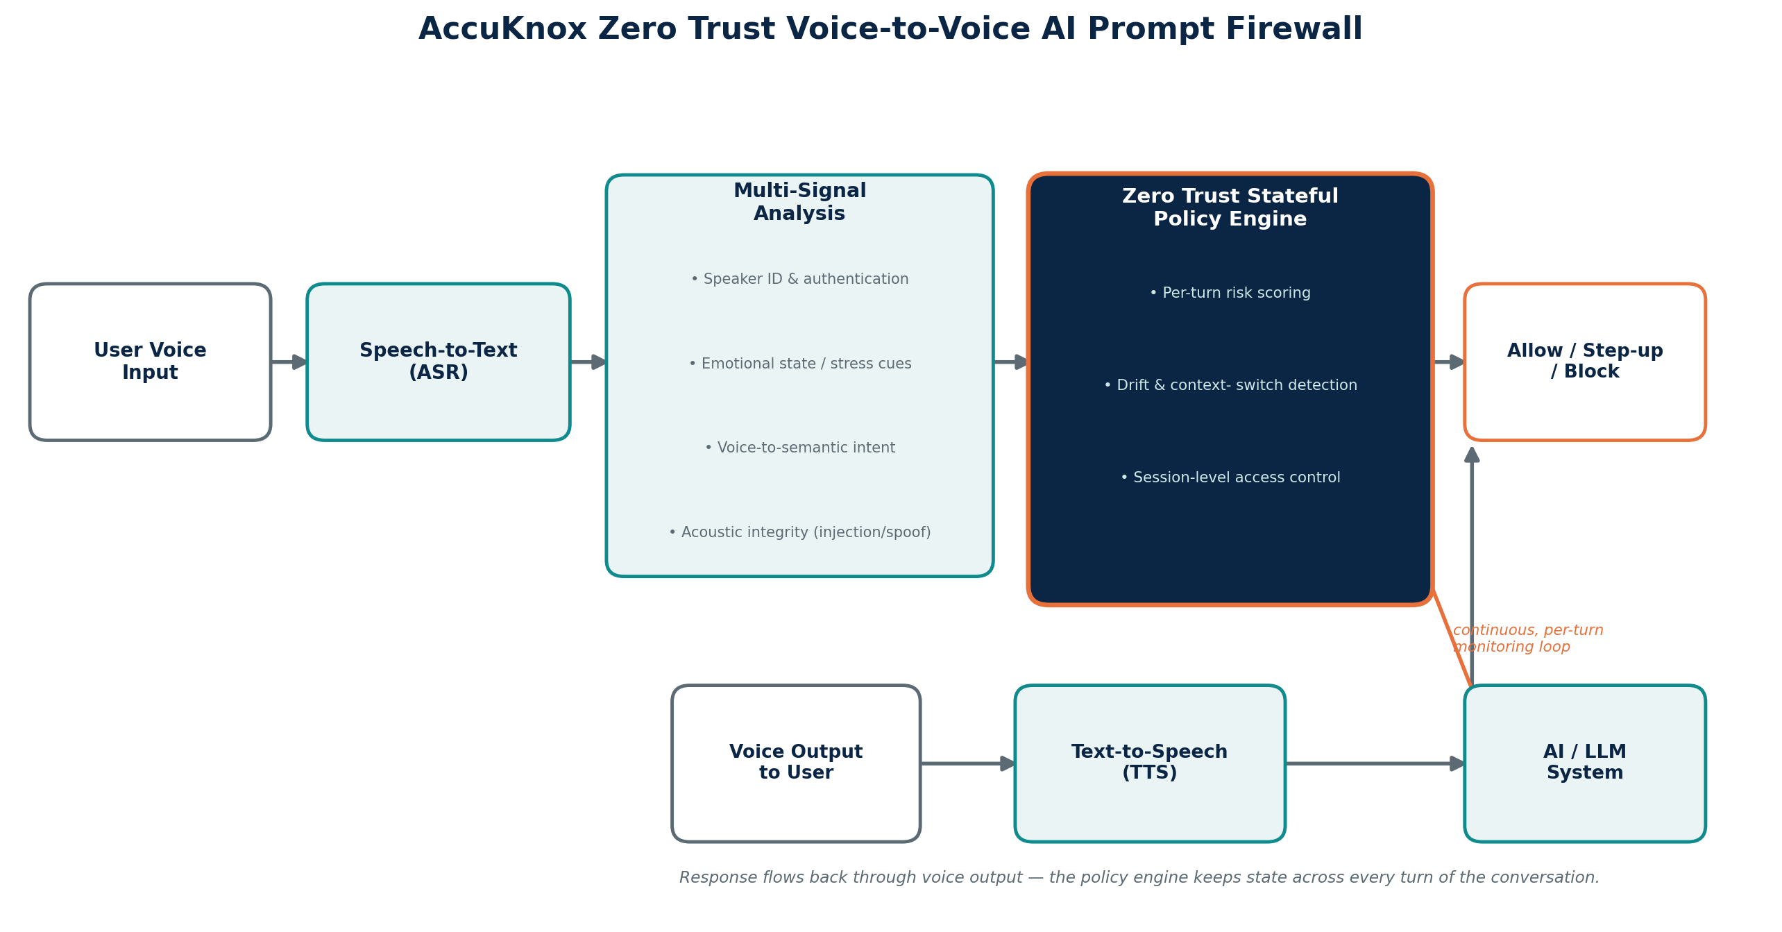
Figure 2. The AccuKnox Zero Trust Voice-to-Voice AI Prompt Firewall pipeline — a stateful policy engine that monitors every turn of the conversation, not just the wake word.
As voice comes in, it’s transcribed and then evaluated across six analysis dimensions simultaneously: speaker ID and authentication, emotional state and stress indicators, background audio and acoustic-injection detection, multi-language and multi-media encoding checks, voice-to-semantic intent mapping, and authority/intent signal verification. Instead of a single pass/fail decision, the policy engine carries state across the whole session, which unlocks capabilities that stateless filters structurally cannot offer:
Table 3 — Core capabilities of the AccuKnox Voice Firewall
Capability | What it delivers
Multi-turn context awareness | Understands intent across a full conversation, not a single instruction
Speaker verification integration | Confirms identity continuity throughout a session and flags mismatches
Real-time risk scoring | Flags emotionally manipulative, coercive, or contradictory conversation flows
Cross-modal correlation | Aligns text, voice tone, and behavioral signals into one threat picture
Drift detection | Catches gradual shifts in tone or requests that may signal manipulation in progress
Zero Trust session control | Applies dynamic access decisions per conversational turn, not just per session

This is why the architecture matters strategically, not just technically. The table below captures why organizations moving voice into mission-critical or regulated workflows should care.
Table 4 — Why it matters
Value proposition | Why it matters
Mission-critical trust | Prevents impersonation in high-stakes voice-command environments (e.g., secure comms, autonomous system control)
Reduced insider-threat risk | Flags coercion, duress, or behavioral drift in real time
Compliance-ready architecture | Aligns with Zero Trust mandates and regulatory frameworks organizations already have to meet
Operational continuity | Reduces fallout from voice-based social engineering or misfires
Scalability across programs | Applies equally to command systems, biometric access, and AI copilots
Rapid prototyping advantage | New assessment methods can be stood up quickly as new attack TTPs emerge

AccuKnox’s team’s ability to rapidly prototype new assessment methods matters because, as Section 1 made clear, the threat landscape is not static — new ultrasonic techniques, new deepfake tooling, and new conversational manipulation patterns surface constantly. A guardrail that can only be updated on a slow release cycle will always be chasing yesterday’s attack. A Zero Trust, stateful policy engine that treats every turn of a conversation as a fresh trust decision — informed by everything that came before it — is built to keep pace instead.

Conclusion
The keyboard-era model of security — sanitize the input, validate the request, move on — was never designed for a world where the “input” is a human voice carrying tone, urgency, authority, and intent across an entire conversation. Every threat covered in Section 1 is real, documented, and already being used against production systems today. Every defense covered in Section 2 helps, but none of them close the gap alone, because they were built to judge a single utterance, not a relationship unfolding turn by turn.
That gap is exactly where voice-driven fraud, impersonation, and mission-critical failures will come from next — and it is exactly the gap AccuKnox’s Zero Trust Voice Firewall is built to close. By keeping state across the conversation, correlating speaker identity, emotional signal, semantic intent, and acoustic integrity in real time, and applying Zero Trust access decisions turn by turn rather than once at the wake word, AccuKnox turns voice from an unguarded new attack surface into a channel that can finally be trusted the way enterprises already expect their networks, endpoints, and cloud workloads to be trusted. Voice is the next keyboard. It’s time it had a firewall to match.

